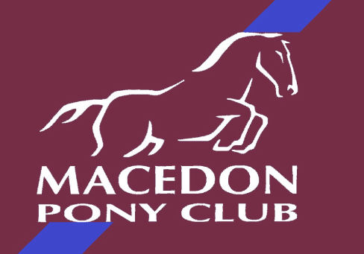 PRESIDENTS REPORT

July Rally

We are very happy we can run our July rally but are sad some 6 families miss out as they live in metro. Our thoughts are with you all and look forward to seeing you all at the August rally.

The July Rally will be strictly following the government guidelines and regulations. Please ensure you read all the information Lizze has sent out.

Social distancing must be maintained and good hand hygiene.

Hospital grade Hand Sanitiser will be available at all arenas and the front gate please use the sanitiser before entry and throughout the day.

The Clubrooms will be locked with no entry permitted.

It is recommended the Covid safe app be downloaded.

If you are sick in any way please do not attend.

You will need to scan the QR code upon entry this is very important.

We will not be having a lunch time meeting so please keep up to date via our website and or facebook. Please note do not just rely on the facebook as our emphasis is on our website.

Please remember to bring lunch, drinks and snacks as we cannot have a canteen.

The roster will not be valid this rally so if everybody can please set up and pack up that would be great.

SHOWJUMPING DAY SUNDAY JUNE 27, 2021 ENTRIES CLOSING SOON

At this stage our Showjumping Day is full steam ahead. We will however need to check all regulations. If you are intending on entering the event please do so. If the event is cancelled you will receive a refund. We will not be accepting late entries so please enter prior to the closing date. If we postpone the event to another day due to restrictions the entries will be carried forward.

Anybody that has sold all there raffle tickets can return the books and money to Liza Bishop at the rally as unfortunately Sharon O’Rourke will not be able to attend due to the restrictions.

If anybody has prizes for the showjumping day that they wish to bring please only give these to Lisa bishop or myself at the rally

UNIFORMS

Well the saddle blankets have arrived and we now have shetland,pony,cob and full they look great. Anybody that wants to buy uniform let me know at the rally and I can sell it straight to you. Unfortunatley due to the lockdown the embrodery did not get finished on the long sleeve polar fleece jumpers and new size 4 polo tops but will be finished as soon as the restrictions lift. We do however have some long sleeve polar fleece jumpers but not small sizes.

I am also looking at ordering some soft shell jackets so if you are interested let me know at the rally. I will have a sample you can look at if you are interested.

STATE GAMES,FLAT AND MUSICAL RIDE.

Our flat teams have been training well prior to the lock down and we hope the day proceeds in 2 weeks at Oaklands. If the restrictions do not allow it will be rescheduled.

COVID SAFE OFFICER

Our covid safe officer is Alison Ayers so please follow any direction she may give you and please read all the information sent out by Lizze. Also please check the pony club victoria website if you are unclear.

Please stay safe and look forward to seeing you all at the Rally.

Thanks Teri Kirkham

0409532821.

President.

